***Shekinah*** is the English transliteration of a Hebrew noun meaning dwelling or settling. It denotes the dwelling or settling of the divine presence of God and his cosmic glory. It is said while in proximity to the Shekinah, the connection to God is more readily perceivable.

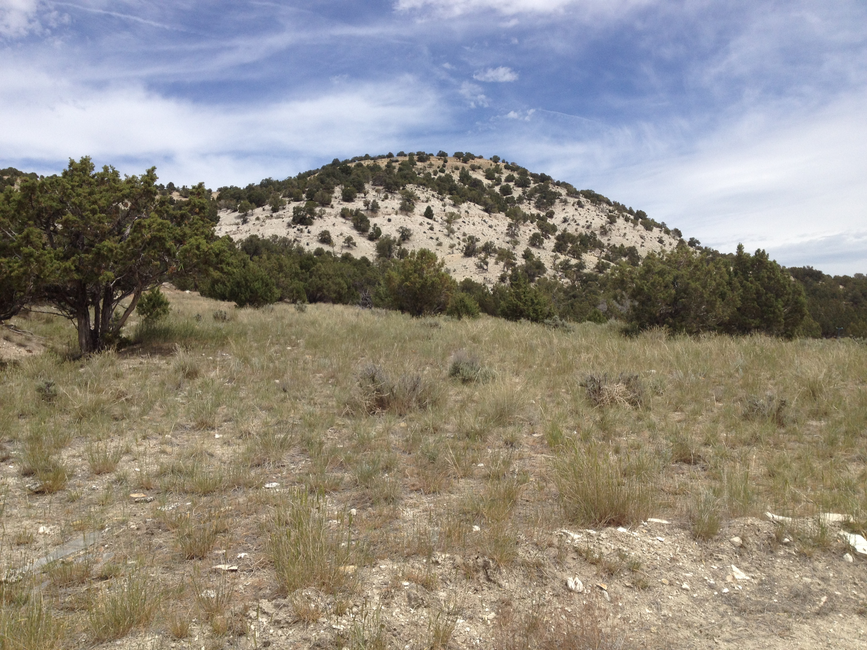

Our mission is to create a community of people who live by spiritual values transcending race, creed, color and religion, who live in peace with no poor among them.

If this vision and mission resonates with you call Susan at 801-400-3242.

info@shekinahecovillage.com www.ShekinahEcoVillage.com

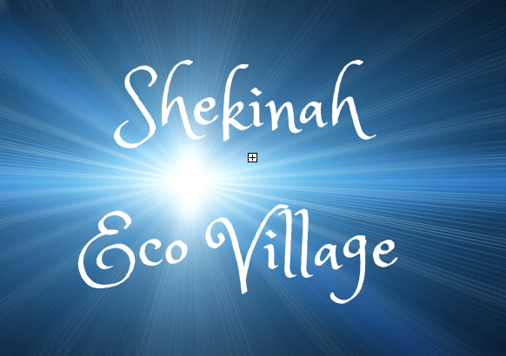

Shekinah Eco-Village P.O. Box 253 Ephraim, Utah 84627

***An Intentional Community for Millennial Living***

Self-Sufficient, Off Grid, Family Friendly, Earth Friendly, Cooperative Community Governed by Spiritual Values

**Located in Sanpete County near Spring City on 90 acres. Road is in, well is dug, subdivision approved.**

**Get Involved**

**Shekinah Eco Village**

**Memberships –** Every adult membership is $1,000. Children up to age 18 are included in their parents’ membership.

**Full Time** – We currently have three home site leases available for $55,000. The subdivision consists of 4 five-acre sites. Each home site is an acre with a combined common area of 4 acres (16 acres total) for large animals, community center, and greenhouses. Well water is available. While electricity is close by, we prefer off-grid utilities.

**Part Time** – We have a Tiny Home area: ***Safe Haven Village*** consisting of either 200 sq ft sheds or a tiny home on wheels. The cost is $2,000 for the lease on the land. Sheds are not to be lived in, but are for storing camping equipment, emergency supplies, etc.

**Volunteer –** Come be a part of one of our special events. Four hours minimum a day of work are required to participate in special events such as sweat lodges, drumming circles, local hikes etc.

**Attend Classes –** Permaculture, Lasagna Gardening, EnduraBlock building, Building with Cob, Vision Quests, and Off Grid Utilities are just a few of the types of classes offered.

**Sponsor -** Sponsor ***Positive Air*** to do programs for schools on self-esteem, healthy living, and entertaining inspiration for high performance living.

**Vision Statement**

Shekinah Eco-Villages are sustainable, green, off–the-grid communities that nurture sovereign and responsible citizens. We are looking for mature, responsible people with skills of all types: teachers, builders, artists, chefs, athletes, professionals, healers, businessmen, musicians, seamstresses and craftsman, to name a few.

We envision a large community center surrounded by twelve to eighteen homes with a comparable number of guest homes nestled in the middle of ninety acres. Working together we can be free of so much: utility bills, mortgages, high food costs, ill health, and stress. We will have creative, fulfilling and personally sustaining work; living and working together, so that people's lives and work are integrated into a unified environment.

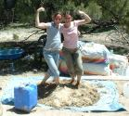

*The community offers workshops and wellness training devoted to health, joy and living sustainability.*

**Values**

**Family Friendly** – Our community is conducive to raising children who are responsible, nurtured, mentally curious, and creative. The adults strive to model healthy behavior.

**Sustainability** - Our building practices, water usage, food production, and energy production aspire to a seven-generation model. We abide by the ethics of Perma-culture.

**Alternative Buildings** – Buildings are various debt-free and earth friendly types that minimize the use of manufactured products: earthships, EnduraBlock, rammed earth, cob, zip-kits, etc.

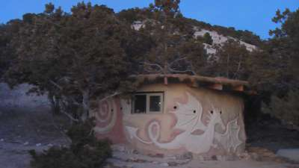

**Personal Sovereignty** – There can be no freedom without responsibility. As a community we support the principles of freedom and we take personal responsibility for our actions and our needs.

**Limitations** - Our community is free of all illegal activities including drugs. We have no public nudity, freeloaders, vulgarity, visible junk, and abusive behavior. Smoking and alcohol use is not permitted.

R